The **Deep Learning Model Analyzer** is a Python-based tool that simplifies video analysis, combining traditional computer vision techniques with advanced deep learning models. The project provides users with the capability to load, process, and analyze video content using edge detection algorithms and YOLOv8 models for object detection. The intuitive PyQt6-based GUI offers real-time control, flexibility, and ease of use.

**Goals:**

• **Simplify Video Analysis with Deep Learning:**

Provide a user-friendly interface that allows users to easily load, analyze, and process videos using deep learning models without needing extensive coding knowledge.

**• Real-Time Object Detection Using YOLOv8:**

Enable users to load YOLOv8 models and perform real-time object detection on video files or camera streams, allowing for dynamic filtering based on classes and confidence thresholds.

• **Integrate Edge Detection for Enhanced Analysis:**

Implement classical edge detection techniques (Sobel, Canny, Laplace of Gaussian) to provide users with the ability to analyze video content through different visual processing methods.

• **Adjustable Video Processing Parameters:**

Offer flexible tools for modifying video frames, including brightness, contrast, cropping, and resizing, allowing users to fine-tune the content for specific analytical purposes.

• **Snapshot and Recording Capabilities:**

Allow users to capture snapshots of video frames and save processed video recordings with the applied settings (e.g., edge detection or object detection) for documentation or further analysis.

**Key Features:**

• **Video Playback**: Load, play, pause, and stop video files for analysis.

• **Camera Input**: Stream real-time camera input for live video analysis.

• **Edge Detection**: Implement Sobel, Canny, and Laplace of Gaussian edge detection algorithms to analyze video frames.

• **YOLOv8 Model Integration**: Load YOLOv8 models for object detection and filter based on selected classes and confidence thresholds.

• **Brightness & Contrast Adjustment**: Fine-tune video frame settings using sliders for brightness and contrast.

• **Cropping & Resizing**: Dynamically crop and resize video frames to focus on specific areas.

• **Snapshot & Recording**: Capture frame snapshots or record video with applied settings and detections.

**Target Users:**

This tool is aimed at Professionals working with computer vision, object detection, and video analysis who need an intuitive tool to test and validate models like YOLOv8 without writing extensive code, Academic researchers or industry professionals conducting experiments with various edge detection algorithms or object detection models for visual recognition tasks.

**Technological Stack:**

* Programming Language: Python
* GUI Framework: PyQt6
* Image Processing: Libraries such as OpenCV or PIL for handling image operations.

**Expected GUI:**

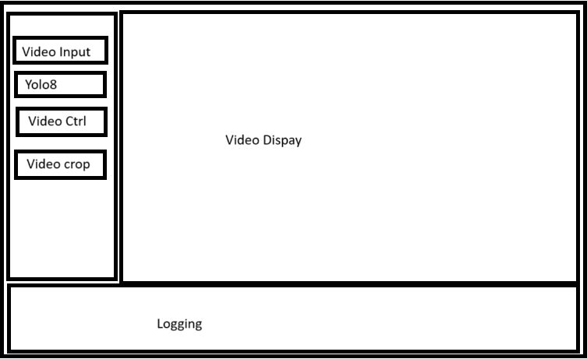

**Limitation**

* **Single YOLOv8 model Integration:** Currently the GUI support only YOLOv8 object detection model

**Conclusion**

The **Deep Learning Model Analyzer** is a comprehensive tool that merges the power of deep learning with classical computer vision techniques, providing a flexible, easy-to-use video analysis platform. The tool empowers users to perform object detection using YOLOv8 and apply edge detection techniques in real-time, without needing extensive programming skills. With its intuitive interface, modular design, and versatile feature set, the analyzer is well-suited for professionals and researchers in fields such as surveillance, media analysis, and data annotation.

The project demonstrates the potential of integrating deep learning models into practical, GUI-based applications, offering an effective solution for real-time video processing and analysis. Future developments could expand on the current functionalities, incorporating more algorithms, model support, and enhancements for more advanced use cases.